**Installation**

We prefer to install istanbul as a "*devDependencies*" in each of our projects:

**npm install istanbul --save-dev**

to check if the installation worked, (*copy-paste and*) run the following command in your terminal:

**node_modules/.bin/istanbul help**

**Simple Example**

For our first example create a file called test.js.

**vi test.js**

type (*or copy-paste*) the following code in the test.js file:

**x = 42;**

**if(false)**

**x =-1;**

Now run the istanbul command to generate a coverage report:

**node ./node_modules/.bin/istanbul cover test.js**

Alternatively you can insert the line

**"coverage": "istanbul cover ./test.js"**

into the scripts section of your package.json and run

**npm run coverage**

This will create a directory in your project called **coverage** where you will find the generated coverage reports. In our case: [learn-istanbul/**coverage/lcov-report**/learning-istanbul/**test1.js.html**](https://github.com/dwyl/learn-istanbul/blob/master) If you open the test1.js**.html** file in your browser you will see a *visual* coverage report:

[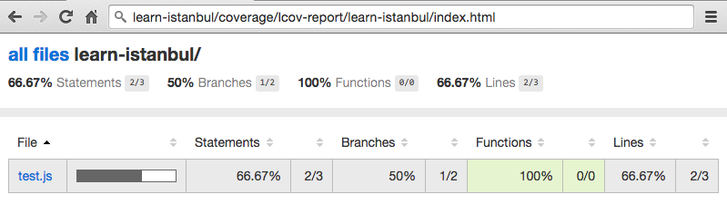](https://cloud.githubusercontent.com/assets/194400/14235269/27f13d9a-f9f1-11e5-9b43-5c8c659717e0.png)

References:

https://github.com/dwyl/learn-istanbul